APPLICATION CHECKLIST
Use this checklist as a tool to ensure that you have all of the components of the application package. Please note, this checklist is for your use only and does not need to be included in the package.

Application
Transmittal Letter
$100 Application Fee
Tax Liability Statement
Letters of Support (If Applicable)
Other Appendices (If Applicable)

When the package is completed, send an electronic version to the Industrial Commission at ndicgrants@nd.gov. Send payment to:

North Dakota Industrial Commission
Attention: Renewable Energy Program
State Capitol – 14th Floor
600 East Boulevard Ave Dept 405
Bismarck, ND 58505-0840

For more information on the application process please visit:
https://www.ndic.nd.gov/renewable-energy-program/rep-applicant-council-information

Questions can be addressed by calling 701-328-3722.

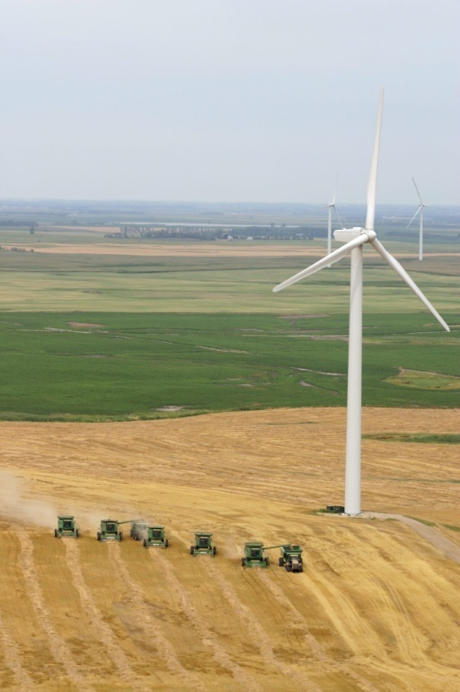
Application

Project Title:

Applicant:

Principal Investigator:

Date of Application:

Amount of Request:

Total Amount of Proposed Project:

Duration of Project:

Point of Contact (POC):

POC Telephone:

POC Email:

POC Address:

Renewable Energy Program
North Dakota Industrial Commission

TABLE OF CONTENTS
Please use this table to fill in the correct corresponding page number.

Abstract | 1
Project Description | 2
Standards of Success
Background/Qualifications
Management
Timetable
Budget
Confidential Information
Patents/Rights to Technical Data

ABSTRACT
Objective:

Expected Results:

Duration:

Total Project Cost:

Participants:

PROJECT DESCRIPTION
Objectives:

Methodology:

Anticipated Results:

Facilities:

Resources:

Techniques to Be Used, Their Availability and Capability:

Environmental and Economic Impacts while Project is Underway:

Ultimate Technological and Economic Impacts:

Why the Project is Needed:

STANDARDS OF SUCCESS
Standards of Success should include: The measurable deliverables of the project that will determine whether it is a success; The value to North Dakota; An explanation of what parts of the public and private sector will likely make use of the project’s results, and when and in what way; The potential that commercial use will be made of the project’s results; How the project will enhance the education, research, development and marketing of North Dakota’s renewable energy resources; How it will preserve existing jobs and create new ones; How it will otherwise satisfy the purposes established in the mission of the Program.

BACKGROUND/QUALIFICIATIONS
Please provide a summary of prior work related to the project conducted by the applicant and other participants as well as by other organizations. This should also include summary of the experience and qualifications pertinent to the project of the applicant, principal investigator, and other participants in the project.

MANAGEMENT
A description of how the applicant will manage and oversee the project to ensure it is being carried out on schedule and in a manner that best ensures its objectives will be met, and a description of the evaluation points to be used during the course of the project.

TIMETABLE
Please provide a project schedule setting forth the starting and completion dates, dates for completing major project activities, and proposed dates upon which the interim reports will be submitted.

BUDGET
Please use the table below to provide an itemized list of the project’s capital costs; direct operating costs, including salaries; and indirect costs; and an explanation of which of these costs will be supported by the grant and in what amount. The budget should identify all other committed and prospective funding sources and the amount of funding from each source. Please feel free to add columns and rows as needed. Higher priority will be given to those projects have matching private industry investment equal to at least 50% or more of total cost.

Project Associated Expense | NDIC’s Share | Applicant’s Share (Cash) | Applicant’s Share (In-Kind) | Other Project Sponsor’s Share
Total

Please use the space below to justify project associated expenses, and discuss if less funding is available than that requested, whether the project’s objectives will be unattainable or delayed.

CONFIDENTIAL INFORMATION
A person or entity may file a request with the Commission to have material(s) designated as confidential. By law, the request is confidential. The request for confidentiality should be strictly limited to information that meets the criteria to be identified as trade secrets or commercial, financial, or proprietary information. The Commission shall examine the request and determine whether the information meets the criteria. Until such time as the Commission meets and reviews the request for confidentiality, the portions of the application for which confidentiality is being requested shall be held, on a provisional basis, as confidential.
If the confidentiality request is denied, the Commission shall notify the requester and the requester may ask for the return of the information and the request within 10 days of the notice. If no return is sought, the information and request are public record.
Note: Information wished to be considered as confidential should be placed in separate appendices along with the confidentiality request. The appendices must be clearly labeled as confidential. If you plan to request confidentiality for reports if the proposal is successful, a request must still be provided.
To request confidentiality, please use the template available at https://www.ndic.nd.gov/renewable-energy-program/rep-applicant-council-information.
If you are not requesting confidentiality, please note that below.

PATENTS/RIGHTS TO TECHNICAL DATA
Any patents or rights that the applicant wishes to reserve must be identified in the application. If this does not apply to your proposal, please note that below.

STATE PROGRAMS AND INCENTIVES
Any programs or incentives from the State that the applicant has participated in within the last five years should be listed below, along with the timeframe and value.

